# Information Visualization

# CHECKPOINT III: Visualization Sketch

G13 – A

**1. Overview**

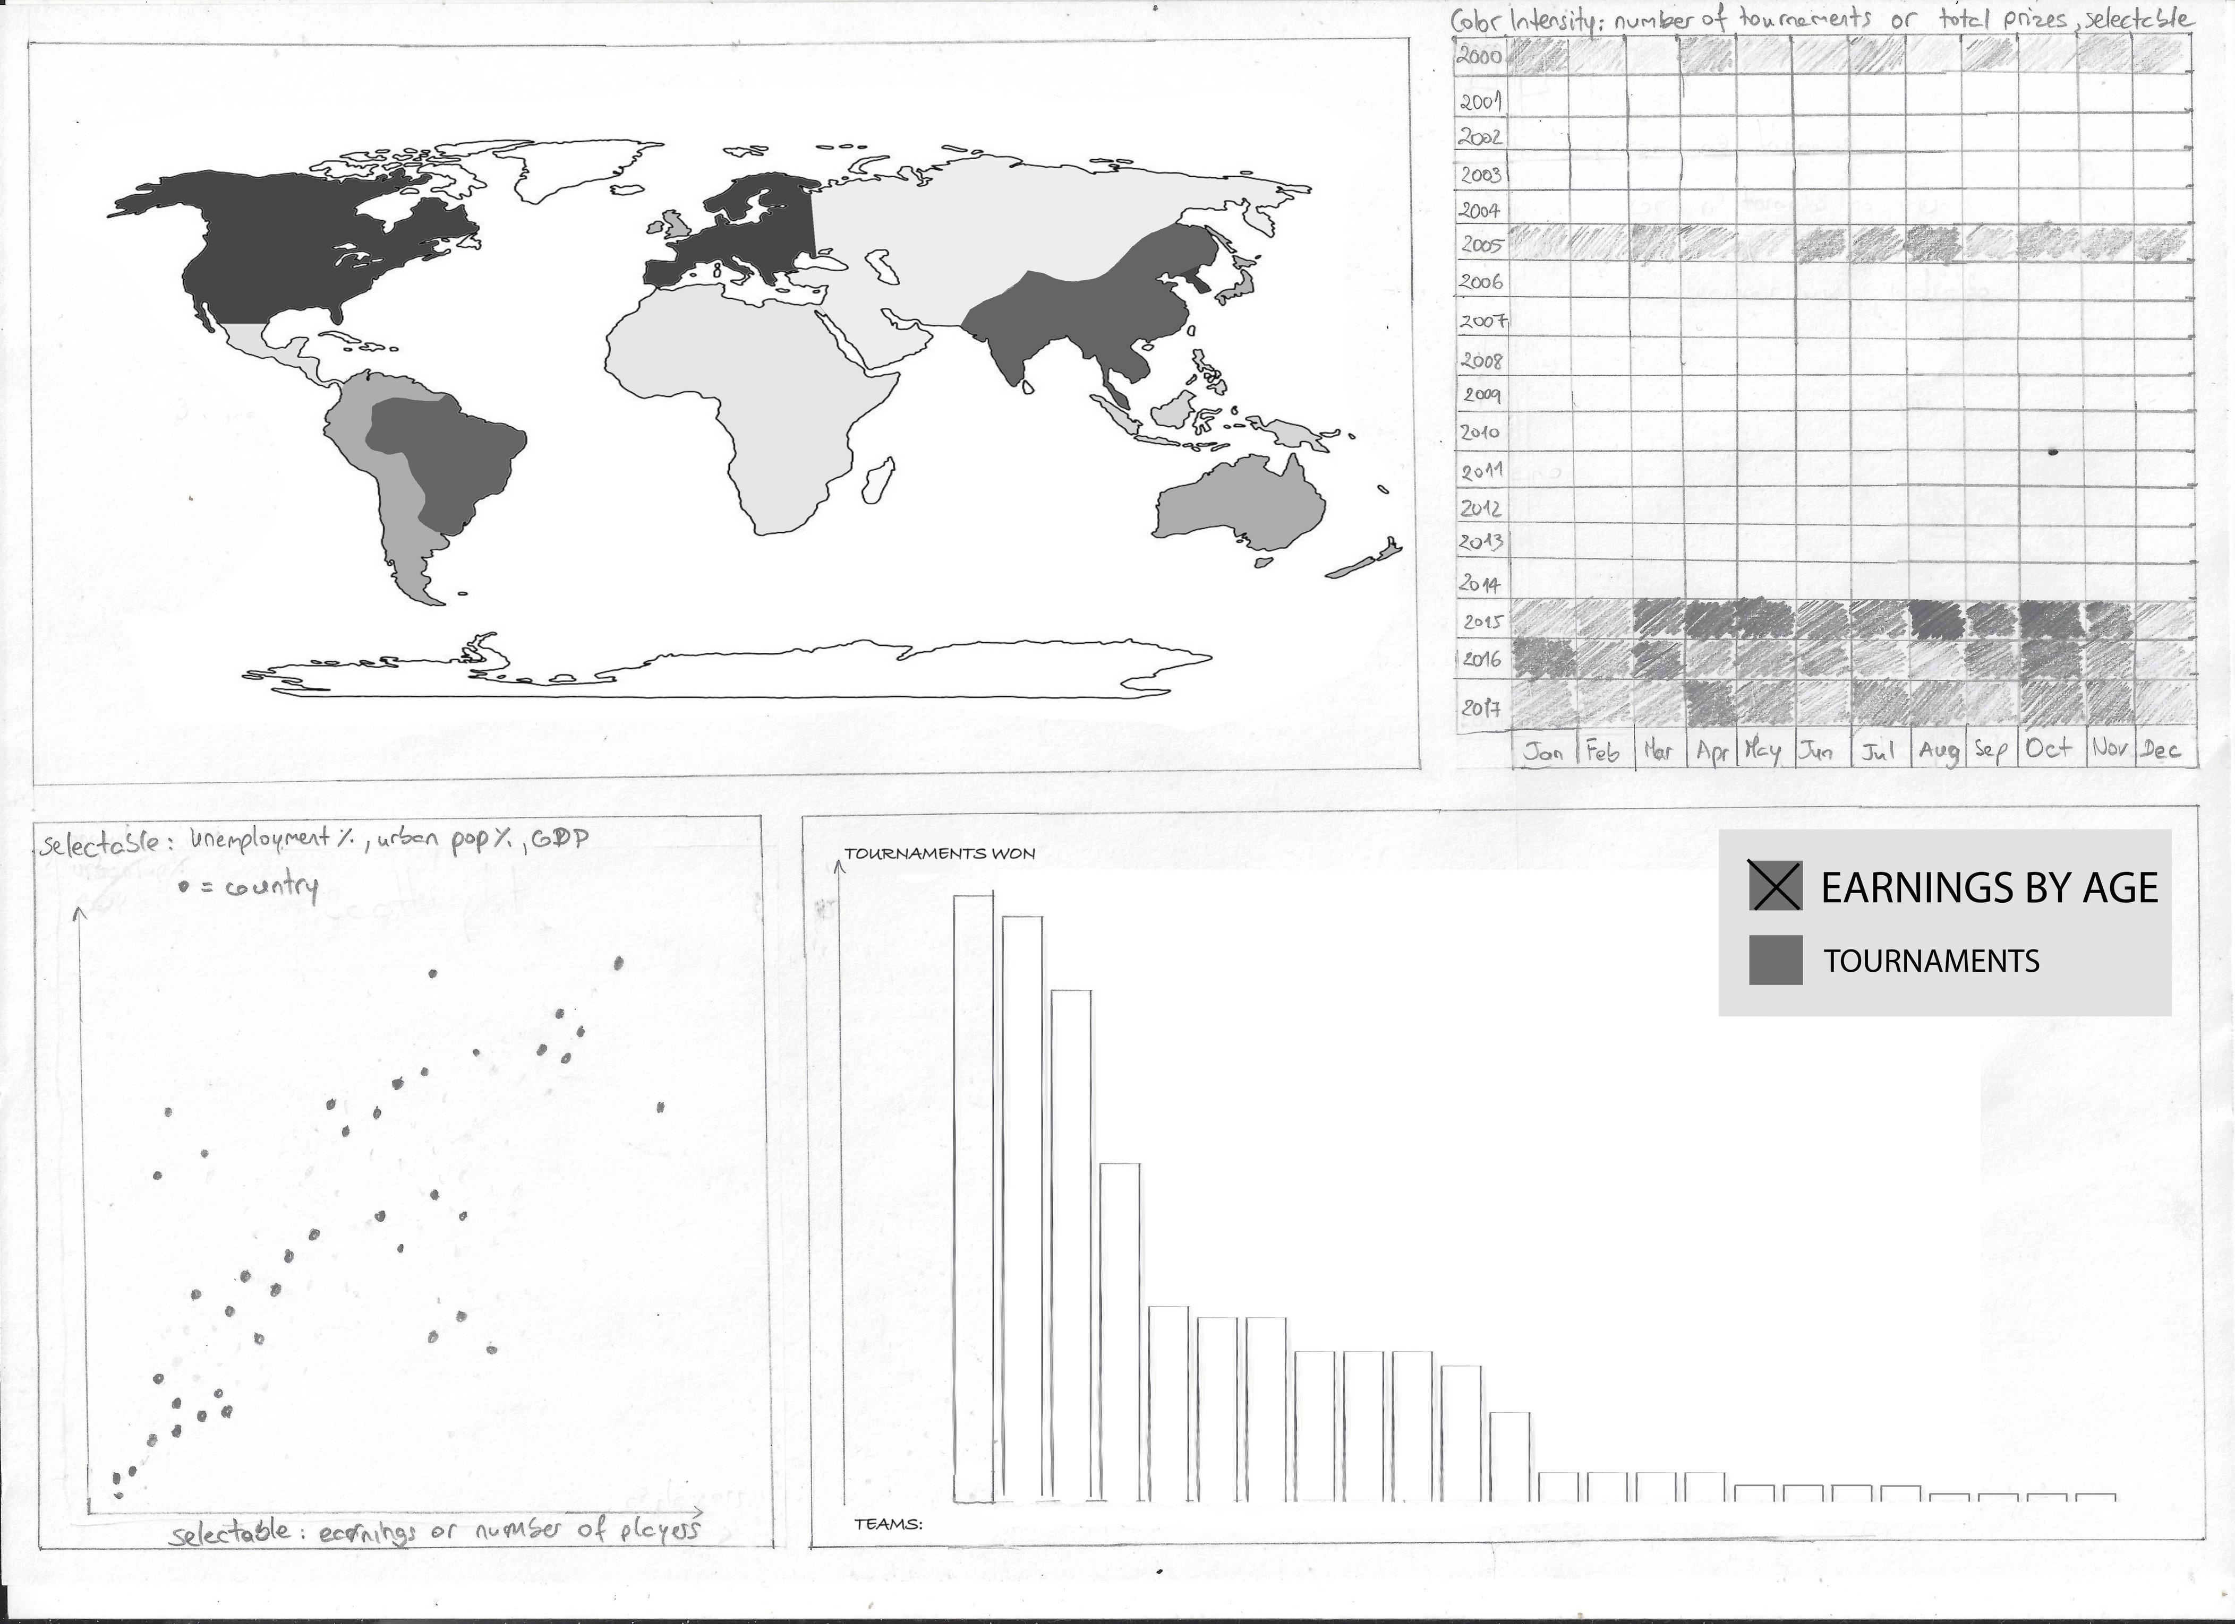

Our visualization will be focused around a Choropleth Map and it will dictate what the other idioms display. This will also be interactable by selecting a given area/country in the map or searching by a specific country name in a dropdown dedicated to it.

The idioms affected by the previous selection are:

1. Scatter plot;
2. Bar chart;

The first will display the unemployment or the urban population rates by the player earnings for the selected area or all the countries if nothing is selected in the Choropleth Map.

The second will show the player earnings in different ages within the selected area or all players if nothing is selected in the Choropleth Map. If a certain square is selected in the Heat Map, the bar chart will display either the earnings/quantity of tournaments for each team or the earnings/quantity of tournaments for each game in the respective month of a given year.

The last idiom will be a Heat Map and it will have the possibility of filtering these tournaments data by teams or games and, as mentioned previously, it will affect the Bar Chart idiom.

**2. Visual Encoding**

Choropleth Map will show the player earnings per country by using the hue of a given colour and highlight the selected area by applying an outline with a high contrast colour to it.

The scatter plot will use different colours for each ratio. Ex: Red for unemployment rate and blue for urban population rate. Each ball represents a different country.

The height of the bars in the Bar Chart represent the earnings amount or quantity of tournaments played.

In the Heat Map, the hue of a given colour is either the quantity of tournaments or the prize USD amount of those tournaments in a given year per month (we can select between both and each one with a different colour).

**3. Idiom and Tasks/Questions**

Choropleth Map answers the following questions:

* **What countries have the highest earnings?**



Bar chart answers the following questions:

* **What organizations earned the most?**
* **What is the age at which players earn the most?**
* **What games have the most earnings?**

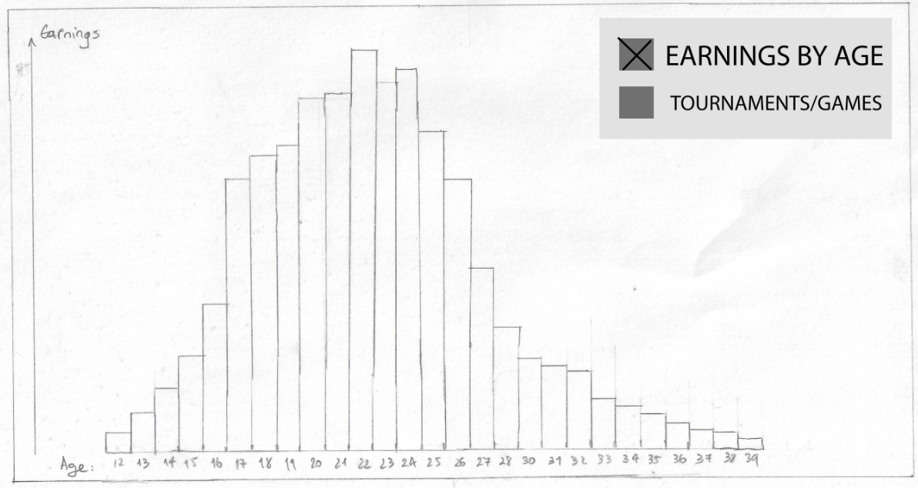

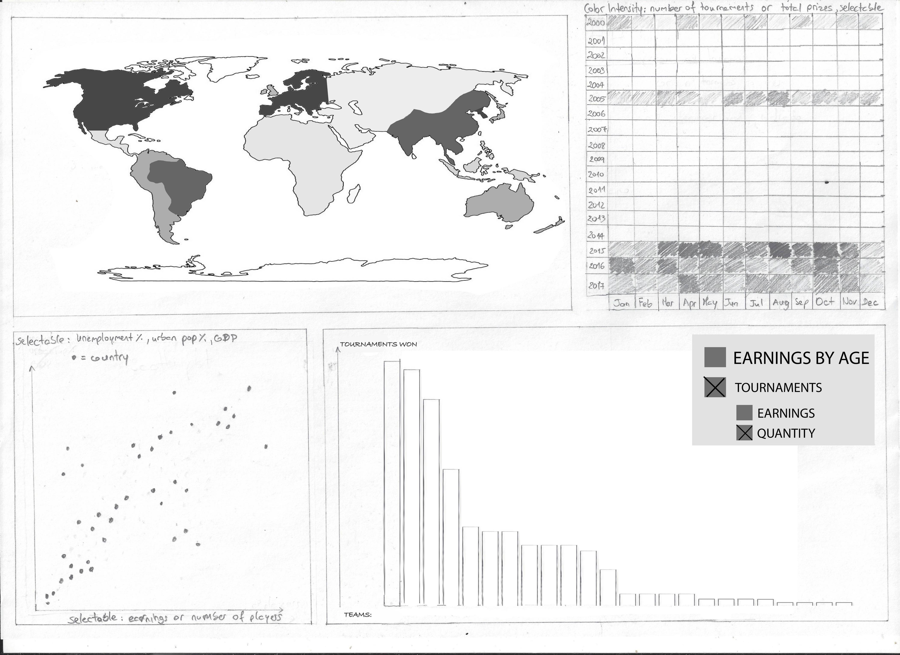

Scatter plot answers the following questions:

* **How does unemployment correlate with player earnings?**



Heat Map answers the following questions:

* **What months are the most active in esports?**

